

Mini Project Report - 04

Master of Computer Application – General
Semester – III

Sub: Web Technologies

Topic: ATM Interface Design
By
Name: NITHISH N
Reg no.: 2511022250066

Faculty Name: VEERA RAGHAV K

Faculty Signature: _______________

Department of Computer Application
Alliance University
Chandapura - Anekal Main Road, Anekal
Bengaluru - 562 106

June 2026
ATM Interface Design

INDEX

Sl. No | Content | Page No.
1 | Introduction | 1
2 | Input Code | 1–2
3 | Output | 3
4 | Conclusion | 3

- INTRODUCTION

The ATM Interface is a simple web-based application designed using HTML and CSS to simulate the user interface of an Automated Teller Machine (ATM). The project provides options such as cash withdrawal, cash deposit, payments, credit card services, account settings, and quick cash access. The main objective of this project is to demonstrate the use of HTML for structuring web pages and CSS for creating an attractive and responsive user interface. It helps beginners understand concepts such as layouts, buttons, colors, spacing, flexbox, and styling techniques used in modern web design.
- INPUT CODE

<html>
<head>
<title>ATM Interface</title>
<style>
.parent {
background-color:rgb(57, 0, 100);
width: 600px; height: 550px; margin: 0 auto; border-radius:20px;
box-shadow: 2px 4px 8px black;
} h2{ color: white; margin-left: 20px;
padding-top: 20px;
} .c1{ display: flex;
justify-content: space-around;
gap:100px;
} p{ color: white; margin-left: 20px;
padding-top: 20px;
} .c2{ display: flex; justify-content: space-around; margin-top: 20px;
} button{ margin-top: 20px; width: 150px; height: 50px;
border:none;

}
</style>
</head>
<body>
<h1 style="text-align: center;">ATM Interface</h1>
<div class="parent">
<div class="c1">
<h2>SBI ATM</h2>
<p>card return</p>
</div>
<div class="c2">
<p><span style="color: skyblue;">Welcome</span><br>Yashwanth</p>
<button>Get Cash</button>
<button>Deposit Cash</button>
</div>
<div class="c2">
<p><span style="color: skyblue;">Account #1</span><br>$2000</p>
<button>payment</button>
<button>Credit Card</button>
</div>
<div class="c2">
<p><span style="color: skyblue;">Savings #2</span><br>$1500</p>
<button>Account Settings</button>
<button style="background-color: aqua;">Others</button>
</div>
<div class="c2">
<button style="background-color: rgb(117, 80, 80); height: 50px; width:
340px; margin-left: 125px; color: white;">$70 Quick Cash</button>

</body>
</html>

OUTPUT

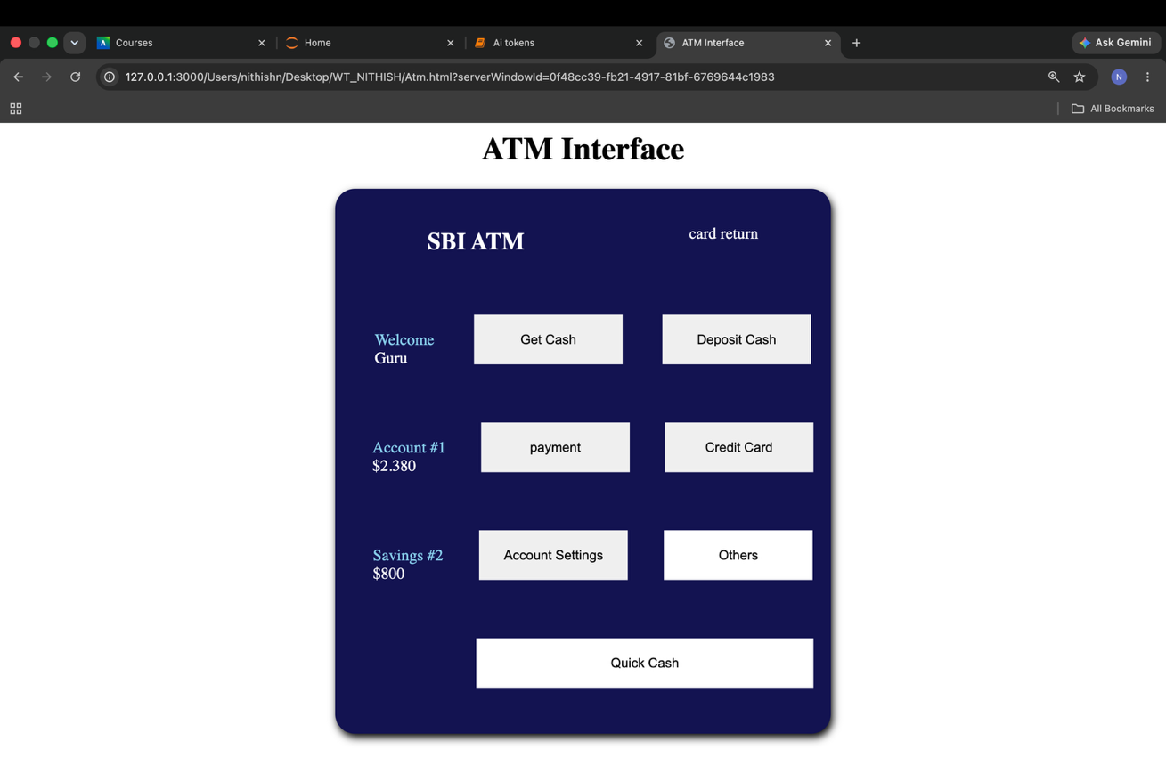

CONCLUSION

The ATM Interface project successfully demonstrates how HTML and CSS can be used to create a visually appealing and user-friendly banking interface. Through this project, users can understand the basics of webpage design, component arrangement, and responsive layouts. The interface provides a realistic representation of ATM functionalities while improving front-end development skills. This project can be further enhanced by integrating JavaScript for functionality and backend technologies for real-time banking operations.

